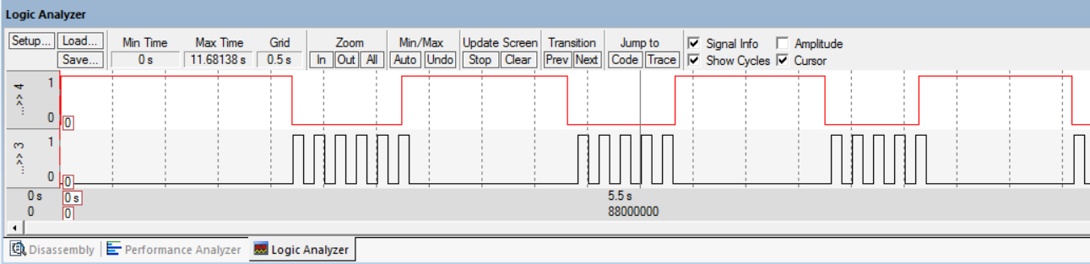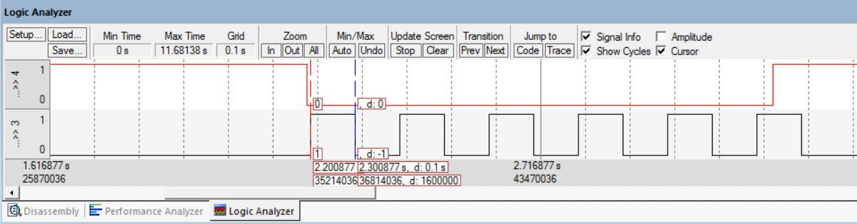

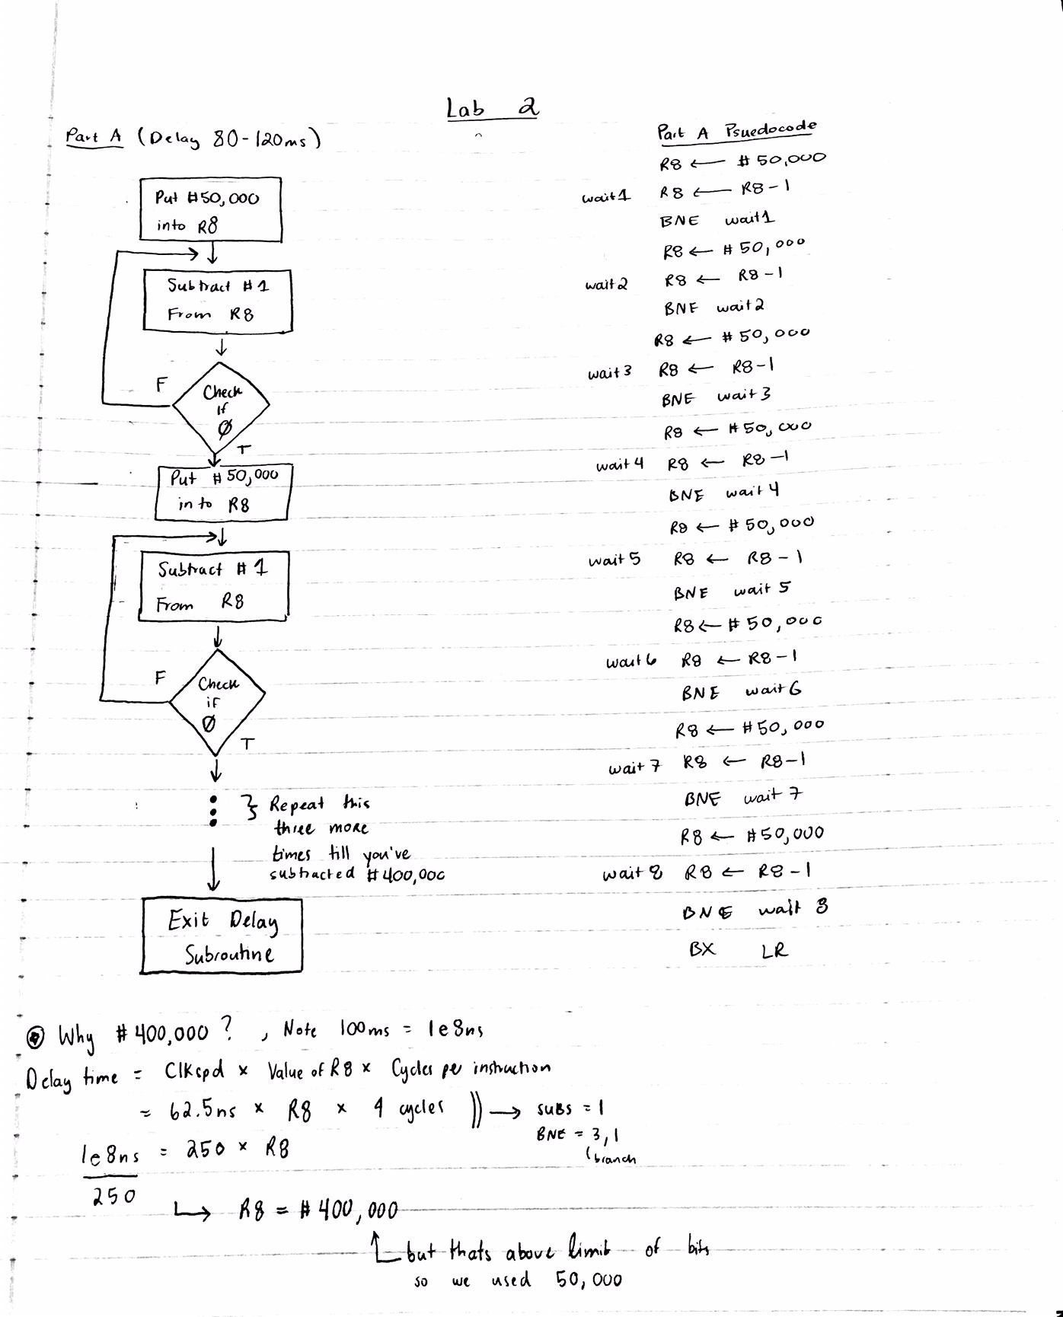

# C:\Keil\EE319KwareSpring2016\Lab2_EE319K_asm\main.s

;****************** main.s ***************

; Program written by: Megan Cooper

; Date Created: 2/12/2016

; Last Modified: 2/12/2016

; Section Wednesday 4-5

; Instructor: Ramesh Yerraballi

; Lab number: 2

; Brief description of the program

; The overall objective of this system an interactive alarm

; Hardware connections

; PF4 is switch input (1 means SW1 is not pressed, 0 means SW1 is pressed)

; PF3 is LED output (1 activates green LED)

; The specific operation of this system

; 1) Make PF3 an output and make PF4 an input (enable PUR for PF4).

; 2) The system starts with the LED OFF (make PF3 =0).

; 3) Delay for about 100 ms

; 4) If the switch is pressed (PF4 is 0), then toggle the LED once, else turn the LED OFF.

; 5) Repeat steps 3 and 4 over and over

GPIO_PORTF_DATA_R EQU 0x400253FC

GPIO_PORTF_DIR_R EQU 0x40025400

GPIO_PORTF_AFSEL_R EQU 0x40025420

GPIO_PORTF_PUR_R EQU 0x40025510

GPIO_PORTF_DEN_R EQU 0x4002551C

GPIO_PORTF_AMSEL_R EQU 0x40025528

GPIO_PORTF_PCTL_R EQU 0x4002552C

SYSCTL_RCGCGPIO_R EQU 0x400FE608

PF4 EQU 0x40025040

PF3 EQU 0x40025020

AREA |.text|, CODE, READONLY, ALIGN=2

THUMB

EXPORT Start

Start LDR R0,= SYSCTL_RCGCGPIO_R

LDR R1,[R0]

ORR R1,#0x20

STR R1,[R0]

NOP

NOP

LDR R0,= GPIO_PORTF_DIR_R

LDR R1,[R0]

BIC R1,#0x10

ORR R1,#0x08

STR R1,[R0]

LDR R0,= GPIO_PORTF_AFSEL_R

LDR R1,[R0]

BIC R1,#0x18

STR R1,[R0]

LDR R0,= GPIO_PORTF_DEN_R

LDR R1,[R0]

ORR R1,#0x18

STR R1,[R0]

LDR R0,= GPIO_PORTF_PUR_R

LDR R1,[R0]

ORR R1,#0x10

STR R1,[R0]

LDR R0,= PF3

LDR R1,[R0]

MOV R1,#0x0

STR R1,[R0]

loop BL Delay

LDR R0,= PF4

LDR R2,= PF3

LDR R1,[R0]

CMP R1,#0

BEQ Toggle

BNE Clear

Toggle LDR R1,[R2]

EOR R1, R1, #0xFF

STR R1,[R2]

B loop

Clear LDR R1,[R2]

AND R1, R1, #0x0

STR R1,[R2]

B loop

Delay MOV R8, #50000

wait1 SUBS R8, #1

BNE wait1

MOV R8, #50000

wait2 SUBS R8, #1

BNE wait2

MOV R8, #50000

wait3 SUBS R8, #1

BNE wait3

MOV R8, #50000

wait4 SUBS R8, #1

BNE wait4

MOV R8, #50000

wait5 SUBS R8, #1

BNE wait5

MOV R8, #50000

wait6 SUBS R8, #1

BNE wait6

MOV R8, #50000

wait7 SUBS R8, #1

BNE wait7

MOV R8, #50000

wait8 SUBS R8, #1

BNE wait8

BX LR

ALIGN ; make sure the end of this section

END ; end of file

|  |  |
| --- | --- |
| **MC Simulated Time Real Time** | |
| **3.562 sec** | **10 sec** |